24.20: a) and b) The equivalent resistance of the combination is 6.0 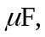 therefore the total charge on the network is: This is also the charge on the 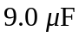 capacitor because it is connected in series with the point b. So:
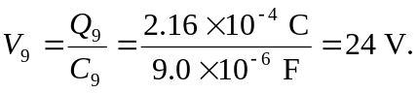
Then
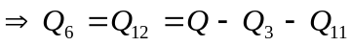
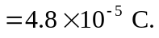
So now the final voltages can be calculated:
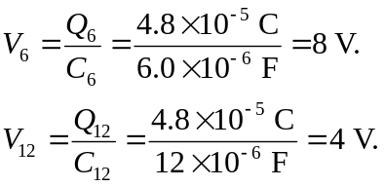
c) Since the 3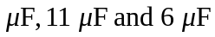capacitors are connected in parallel and are in series with the 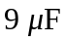 capacitor, their charges must add up to that of the capacitor. Similarly, the charge on the 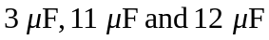 capacitors must add up to the same as that of the capacitor, which is the same as the whole network. In short, charge is conserved for the whole system. It gets redistributed for capacitors in parallel and it is equal for capacitors in series.

